**“Automation of Drowsiness Alert System for Driver in Motor Vehicle in Bangladesh”**

**Md. Al Amin**

**2016-3-60-058**

**East West University**

**Sayam Hossain Bhuiyan Aumy**

**2016-3-60-013**

**East West University**

**Nahid Hasan Ashik**

**2017-2-60-080**

**East West University**

**Abstract**

One of the major cause of road accident is the drowsiness of the all over the world. Every year many death and fatality are occurred on the road due to this reason. The goal of this project is to introduce a system for preventing and decreasing the probability of the road accident from the drowsiness of motor vehicle’s driver. We propose a system with micro controller system integrating with IR and LiDar sensor. It mainly will help to avoid any kind of accident from the drowsiness of the motor vehicle’s driver whether it is caused by also drinking alcohol or the lack of the sleep.

**Introduction**

Driving a motor vehicle while sleepy whether it is caused by drinking alcohol or the lack of the sleep is commonly referred to as drowsy driving.[1] Driving while continually impaired by lack of sleep is known as sleep-divested driving. It can damage the human brain just as much as alcohol can, and it is a major contributor to many car accidents. Drowsiness affects mental alertness and heightens the chance of being affected by a variety of factors, including exhaustion, sleep deprivation, and medication use. A statistics estimate that annually 76000 injuries and near about 1200 deaths can be attributed to fatigue related crashes[4]. The implementation of the low cost drowsiness detective also be a challenging in automation industry. IR sensor and LiDar technology can play a significant role for reducing the accident.

**Background**

In Bangladesh, road accident and the damage for the accident are now serious problem. In recent years there have been several protests for stop the growing accidents in the road. There is no doubt that one of the greater number of road accidents and resultant fatalities are caused by irresponsible and inexperienced reckless driver. Because of their unhealthy sleep routine and the drinking habit, drowsiness take plays on their face and incident happen.

According to study conducted by the Accident Research Centre(ARC). of BUET, 12,000 lives are claimed to death and near about 35,000 injuries in Bangladesh. About 1.6 million motorized and approximately over 3 million non-mtorized vehicles are running in the road [4]. The matter is very severe in international perspective. Each year half million people die and 10-15 millin people are injured in road accidents worldwide[5].

Road accidents are occurred due to bad driving or driving related problems. Now a days people are getting licenced without any proper authorization in Bangladesh. That’s why lots of accident are happening due to the lack of skill and neglagency of the precaution of the driver. Driver are not aware of their sleep condition. They don’t give the importance of their health before driving and also drink the alcohol during the driving. Therefore, factor of the accident by drowsiness are common in Bangladesh’s road accident.

There should must be take the immediate action against this matter. Drowsiness detection and implementing the technology can play vital role for reducing or preventing the unwanted accident due to drowsiness.

Though day by day according to alcohol use of driver is decreasing in Bangladesh because of the initiative of government authority but drowsiness related accident is growing. Besides for the investigation purpose we have to find the possible reason like drowsiness.

By thinking all drowsiness detection system can help preventiong the accident as well as it can help the investigation if we can record the data of the driver condition.

**Related Work**

The process of development of drowsiness detection system started back in 1990’s. Hiroshi Ueno with his teammate stared work on that. They mainly work by images for detection drowsiness[6]. Later many researchers have done significant work to detect drowsiness on available technology on their time. Volkswagen uses the Bosch Driver Drowsiness Detection system.

**Proposed Model**

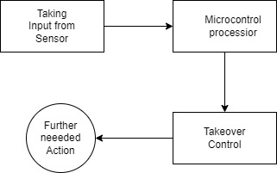

Fig. 3. Hardware Design.

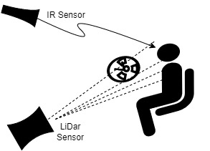

Fig. 2. Graphical Representation.

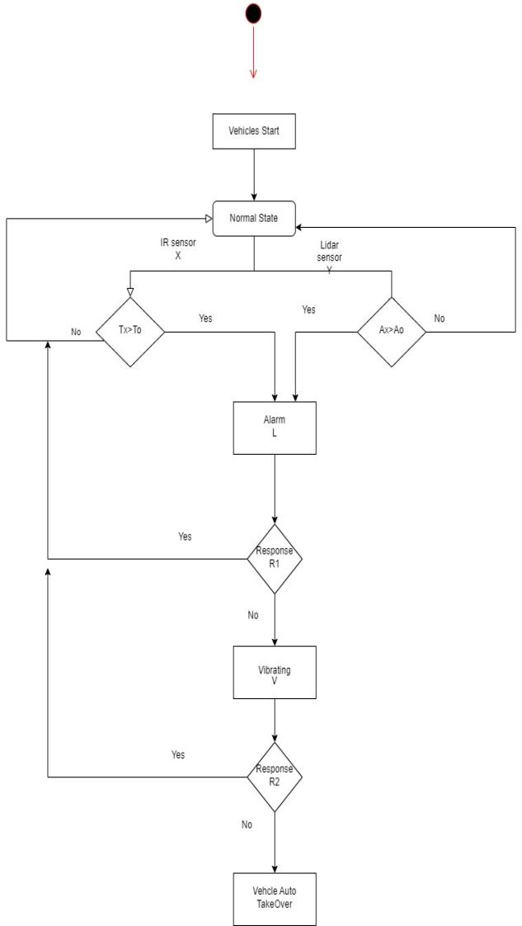

Fig. 3. Block Diagram of drowsiness detection system.

**Basic model of the system:**

The block diagram of the system consists of:

1) Eye blink sensor (IR): To sense the duration and frequency of eye blinks.

2) Lidar: To calculate face angle.

3) Buzzer: Alarm drowsiness detection.

4) Vibrator.

**Methodology**

S=Vehicles Start

N=Normal State

L =Alarm

R1= Response of Eyeblink Alarm

R2= Response of vibrating Alarm

Tx=Input of the IR ray sensor data

To=Threshold time of eye close

Ax=Angle of the face

Ao=Threshold Angle of the face

V=Steering-Wheel Vibrating

O=Auto Takeover

Context Free Grammar:

S→ N

N→ XY

X→ L|N

Y→ L|N

L→ R1

R1→ N|V

V→ R2

R2→ N|T

Parsing

Considering a situation where where driver take Tx time which is greater than To time.

**Limitation**

Here we only show the drowsiness detection along with the alarm and if the driver response is not initiated after drowsiness detection auto takeover. But after takeover, further execution process will be the field where many more work for the safety of the motor vehicle from accident.

**Conclusion and future work**

In Bangladesh now-a-days its a burning matter for reducing road accident. We as engineer have to take initiative for the desired slolution. This project can play a significant role in this field. Besides in future if we integrating with the IoT, we can use it for the investigation purpose after each accident. As there is also a challenge for finding the reason and make a proper transparent report of the road accident. Moreover the data also can be use to the nearest police for live purpose, if the driver constantly avoid the alram of the drowsiness sign.

This project controls eye blink using IR sensor and contribute for getting face angle to detect concentration state of the driver. There are also huge scope for research and development.

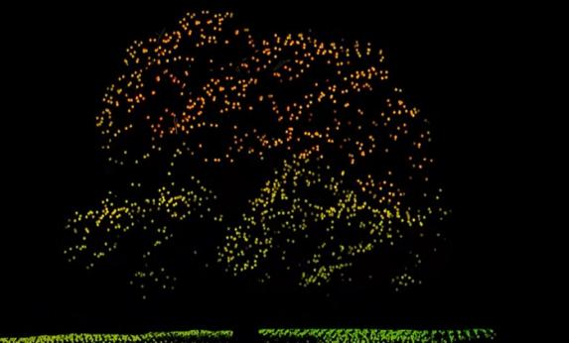

Fig. 1. View a



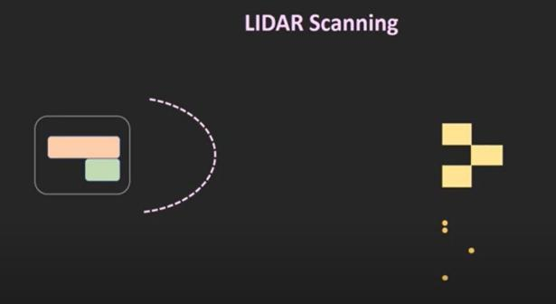

**Acknowledgement**

**References**

[1] Drowsy Driving-Sleep and Sleep Disorders. 2017. Available online: https://www.cdc.gov/sleep/about_sleep/drowsy_driving.

html (accessed on 6 June 2022).

[2] Hoque, M. M. 2004. ‘The road to Road safety: Issues and Initiatives in Bangladesh’. Regional Health

Forum, vol.8, issue 1, pp.39-51.

[3] H. Song, J. Gong, J. Song, and J. Yu, “Protocol

oblivious forwarding (POF),” 2013, Available at:

http://www.poforwarding.org.

[4] Weirwille, W.W. (1994). “Overview of Research on Driver Drowsiness Definition

and Driver Drowsiness Detection,” 14th International Technical Conference on

Enhanced Safety of Vehicles, pp 23-26.

[5] Odgen K.W. “Safer Roads-A guide to Road Safety Engineering”, Institute of Transportation Studies,

Department of Civil Engineering, Melbourne, Australia, 1996.

[6] H. Ueno, M. Kaneda, and M. Tsukino, Development of drowsiness detection system,

Proc. VNIS’94 - 1994 Veh. Navig. Inf. Syst. Conf., pp. 15–20, 1994.

[7] The fatique detection system implemented in cars Ford {Available –

2017.06.01:http://www.technowinki.onet.pl/motoryzacja/system-monitorowaniakoncentracji-kierowcy-w-samochodzie-ford-focus/6f4kdg} (in Polish).

[8] Gogineni Lakshmi Swetha , Suresh Angadi. "A Pre-emptive Susceptive Design for Drowsy Driving Detection System ". International Journal of Engineering Trends and Technology (IJETT). V4(4):917-920 Apr 2013. ISSN:2231-5381. www.ijettjournal.org.

[9]